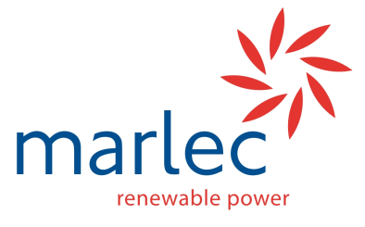
Marlec Engineering Co Ltd
Customer Enquiry for System Sizing

Thank you for contacting us about the system that you propose to power using wind and solar energy. Our technical sales team at Marlec are here to help you achieve a successful outcome. Please fill out the details of your application below so that we can offer you the best possible renewable power solution specific to your application.
Company | Name | Project Name

Profile of Use
1. Describe the application

2. Describe any seasonal variations in how the application will operate:

Power Consumption
Please complete the columns below with as much information as is available:
Device | Voltage | Active  Power or Current Draw | Peak Power or Current Draw on  Start-up | Standby Power or Current Draw | Total  Time component is Active each day | Days per week in use | Total Power or Current each day

Location
In which Country will the system to be used? (If this is for a specific location please send details of that location)

Existing Equipment
If you already have some elements of a system, eg batteries 12V 100Ah, that you would like to incorporate please list them here:

Any other information:

Thank you for taking the time to give us this information. In understanding what you want to achieve we will recommend a solution incorporating the best products available from our own Rutland Windchargers and controllers with solar panels from the leading manufacturers. Please return this form by fax to +44 (0)1536 400211 or email david@marlec.co.uk Call us to discuss your system on +44 (0)1536 201588

